Our Approach 1
Code and Images 1

Our Approach
To get the segments of the image, we have used mean shift segmentation. As seen in previous question, this algorithm does a good work of segmenting image into contour. To get these contours we have used mean shift segmentation with h_{r}=1, number of iterations as 20. We have run the segmentation twice on the image with h_{s} = sqrt (height of image) and h_{s} = sqrt (width of image). We used this heuristic because we observed that for smaller image size, the segmentation result with smaller value of h_{s} was better. After getting these segments, we perform clustering using the kmeans algorithm. For doing this clustering, we also use the spatial distance of the pixels. To perform this in code, we convert the 3-channel input image to 5 channel images with 4th channel as the x index and 5th channel as the y index. Using this 5-channel matrix we perform kmean with 3 cluster centres. We chose 3 centres so that one cluster will be restricted to foreground and its neighbouring region, and the other 2 clusters are restricted to pixels in background. These background pixels may have regions similar to those of foreground, but due to introducing the extra channels with x and y coordinate, these do not get considered in the foreground. This helped us remove a lot of false positives in the foreground.
Using the masks generated we use some more heuristics to clean it up and restrict the region of interest. The methods used for cleaning the masks are mentioned below:
- Consider all the horizontal pixels at the centre of the mask. If these pixels sum to more than a threshold (3 in our case), we shift the considered horizontal line of pixels upwards by 1. The instant, sum of the pixel goes below the threshold, we set all the pixels above the obtained line to 0. Similar operation is done by shifting the horizontal line downwards, and also considering a vertical line at the centre and shifting it leftwards and rightwards.
Due to this, the pixels outside the bounding box of the foreground at the centre become 0.
- Next, after observing the white patches outside the foreground we specifically set to 0 manually hardcoded regions.
- We fill up (set to 1) any “holes” which are formed with the surrounding pixels of value 1, which would only be in the foreground.

The distance measurement is performed by iterating through each pixel in the mask, and calculating the distance. For measuring the shortest distance from any pixel in the background to the foreground, we create multiple disk filters (set all non-zero values as 1, and then normalize) with radius between 1 and alpha, following the idea of binary search. The algorithm is as follows:
- Set initial radius as r = alpha. And the variables low=0 and high=alpha.
- Evaluate the sum of products (cross-correlation) by overlapping the filter on the region under consideration in the mask. If the sum of products is greater than 0, we reduce the radius as (low+r)/2, otherwise we increase radius to (r+high)/2. This is repeated in a loop until the difference between high and low goes below certain threshold (2 in our case). After this, we use the disk filter of found radius and filter the original image.
- For the corner and edge pixels, the disk filter is trimmed appropriately (centre pixel of filter is ensured to match with the pixel under consideration), and then re-normalized.
- Also, for the first instant we check if the sum of products is zero, in which case we report the radius as alpha immediately, and filter the original image with it.
- Note that we have scaled the images to improve the performance and speed up the process. Due to this, we have also scaled the given alpha with the same factor.

Also, since the segmentation task gives us 3 foreground masks, the images mentioned below are corresponding to the best mask given by the segmentation.

Code and Images
myNumOfColors = 200;
myColorScale = [ [0:1/(myNumOfColors-1):1]' , [0:1/(myNumOfColors-1):1]' , [0:1/(myNumOfColors-1):1]' ];
img1 = imread('../data/flower.jpg');
figure(), imagesc(img1), title("Original Image"), colormap(myColorScale), colormap jet, daspect([1 1 1]), colorbar, truesize;
scale = 0.65;
scaledImage = double(imresize(img1, scale));
[c1, segment] = Segmentation(img1, scale);
for i=1:3
c1(:,:,i) = cleanMask(c1(:,:,i), 3);
c1(145:end,:,i) = 0;
c1(:,:,i) = imfill(c1(:,:,i), 'holes');
end
for i=1:3
foreImg = scaledImage;
backImg = scaledImage;
for j=1:3
foreImg(:,:,j) = c1(:, :, i).*scaledImage(:,:,j);
backImg(:,:,j) = (1-c1(:, :, i)).*scaledImage(:,:,j);
end
figure(), imagesc(c1(:, :, i)), title("Mask"), colormap(myColorScale), daspect([1 1 1]), colorbar, truesize;
figure(), imagesc(uint8(foreImg)), title("Foreground Image"), colormap(myColorScale), colormap jet, daspect([1 1 1]), colorbar, truesize;
figure(), imagesc(uint8(backImg)), title("Background Image"), colormap(myColorScale), colormap jet, daspect([1 1 1]), colorbar, truesize;
[filteredImage, radiusMatrix] = filterImage(scaledImage, c1(:, :, i), 20*scale, 2);
figure(), imagesc(uint8(radiusMatrix*255)), title("Radius Contour Image"), colormap(myColorScale), daspect([1 1 1]), colorbar, truesize;
figure(), imagesc(filteredImage), title("Final Filtered Image"), colormap(myColorScale), colormap jet, daspect([1 1 1]), colorbar, truesize;
end
for i=1:5
r = 0.2*i*20;
filt = fspecial('disk', r);
filt(filt>0) = 1;
[fs, ~] = size(filt);
rad = (fs-1)/2;
cover = zeros(41,41);
cover(21-rad:21+rad,21-rad:21+rad) = filt;
strTitle = "Disk Filter with Radius %0.1f alpha";
figTitle = sprintf(strTitle, 0.2*i);
figure(), imagesc(uint8(cover)), title(figTitle), colormap(myColorScale), daspect([1 1 1]), colorbar, truesize;
end
img2 = imread('../data/bird.jpg');
figure(), imagesc(img2), title("Original Image"), colormap(myColorScale), colormap jet, daspect([1 1 1]), colorbar, truesize;
scale = 0.25;
scaledImage = double(imresize(img2, scale));
[c2, segment] = Segmentation(img2, scale);
for i=1:3
c2(:,:,i) = cleanMask(c2(:,:,i), 5);
c2(60:end,1:75,i) = 0;
c2(1:20,80:end,i) = 0;
c2(1:40,110:end,i) = 0;
c2(115:end,1:120,i) = 0;
c2(:,:,i) = imfill(c2(:,:,i), 'holes');
end
for i=1:3
foreImg = scaledImage;
backImg = scaledImage;
for j=1:3
foreImg(:,:,j) = c2(:, :, i).*scaledImage(:,:,j);
backImg(:,:,j) = (1-c2(:, :, i)).*scaledImage(:,:,j);
end
figure(), imagesc(c2(:, :, i)), title("Mask"), colormap(myColorScale), daspect([1 1 1]), colorbar, truesize;
figure(), imagesc(uint8(foreImg)), title("Foreground Image"), colormap(myColorScale), colormap jet, daspect([1 1 1]), colorbar, truesize;
figure(), imagesc(uint8(backImg)), title("Background Image"), colormap(myColorScale), colormap jet, daspect([1 1 1]), colorbar, truesize;
[filteredImage, radiusMatrix] = filterImage(scaledImage, c2(:, :, i), 40*scale, 2);
figure(), imagesc(uint8(radiusMatrix*255)), title("Radius Contour Image"), colormap(myColorScale), daspect([1 1 1]), colorbar, truesize;
figure(), imagesc(filteredImage), title("Final Filtered Image"), colormap(myColorScale), colormap jet, daspect([1 1 1]), colorbar, truesize;
end
for i=1:5
r = 0.2*i*40;
filt = fspecial('disk', r);
filt(filt>0) = 1;
[fs, ~] = size(filt);
rad = (fs-1)/2;
cover = zeros(81,81);
cover(41-rad:41+rad,41-rad:41+rad) = filt;
strTitle = "Disk Filter with Radius %0.1f alpha";
figTitle = sprintf(strTitle, 0.2*i);
figure(), imagesc(uint8(cover)), title(figTitle), colormap(myColorScale), daspect([1 1 1]), colorbar, truesize;
end
toc;
Elapsed time is 206.949686 seconds.

Flower Image (scale factor 0.5):
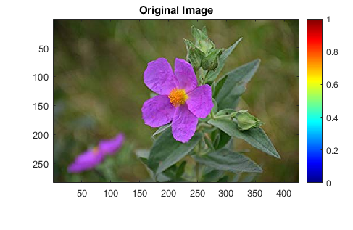
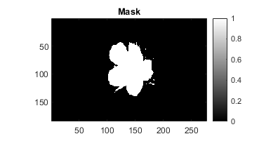
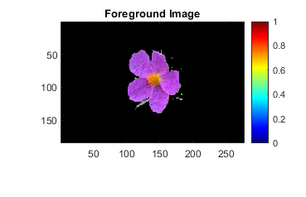
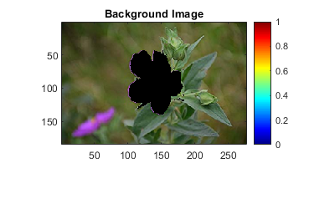
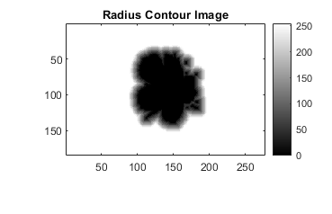
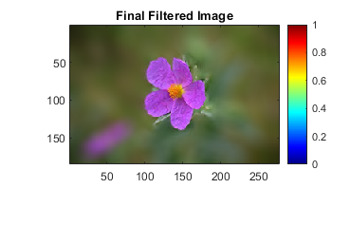

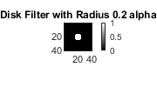
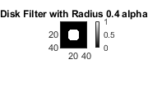
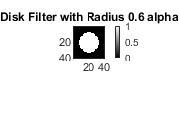
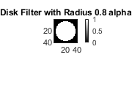
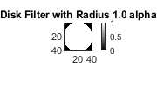
The disk filters shown here are with the actual radius, in normal scale, with respect to given alpha. The filters used for the filtering process would be the corresponding scaled versions of these.

Bird Image (scale factor 0.25):

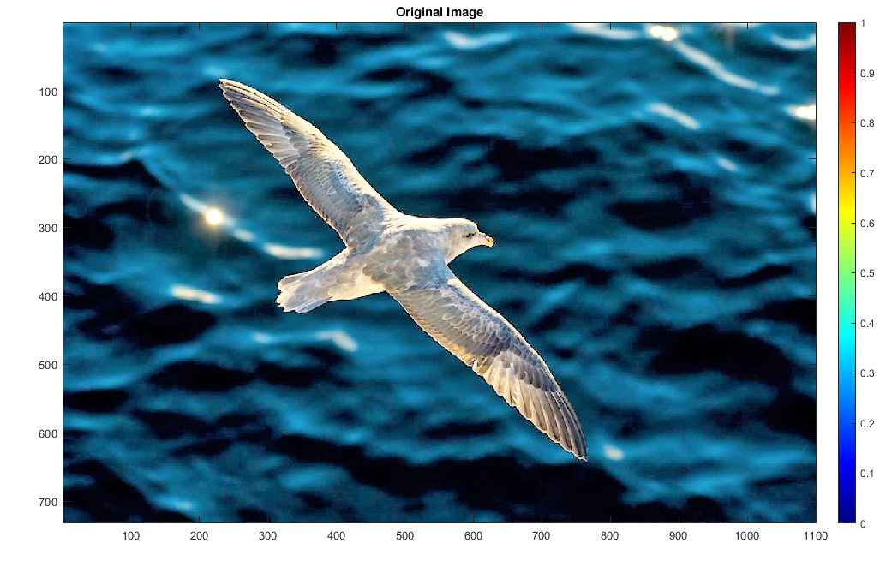

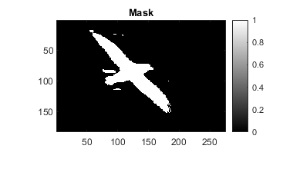
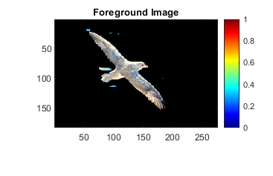
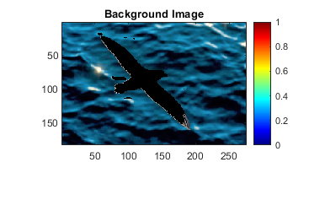
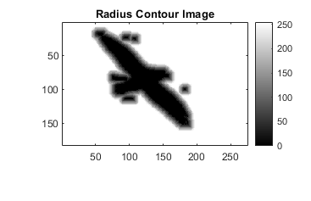
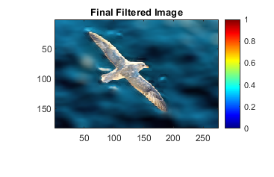
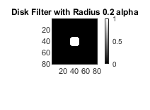
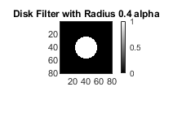
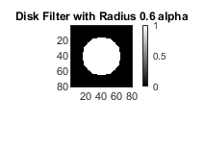
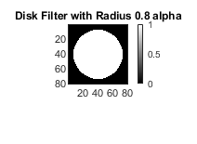
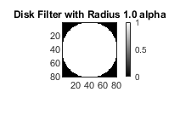
The disk filters shown here are with the actual radius, in normal scale, with respect to given alpha. The filters used for the filtering process would be the corresponding scaled versions of these.

Published with MATLAB® R2020a

